When you use an online utility websites such as web ftp, online photo editing etc, you can notice that they have a custom right click context menu which has options and links in favor of their service and functionality. If you have the same kind of requirements, you can also create one on your own using jQuery.
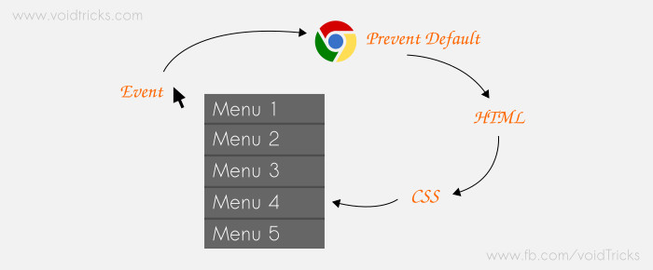

Basic Setup
Create a simple HTML file with jQuery library included.

<!DOCTYPE html>
<html>
<head>
<title>Custom Right Click Context Menu</title>
<script type="text/javascript" src="https://code.jquery.com/jquery-1.11.3.min.js"></script>
</head>
<body>
//This is the menu block
<div class="custom_context_menu">
<ul>
<a href="#"><li>Menu 1</li></a>
<a href="#"><li>Menu 2</li></a>
<a href="#"><li>Menu 3</li></a>
<a href="#"><li>Menu 4</li></a>
<a href="#"><li>Menu 5</li></a>
</ul>
</div>
</body>
</html>

CSS
Initially menu div should be hidden. We can bring it into action whenever we want using jQuery.

.custom_context_menu{
width: 100px;
background: #fff;
color: #fff;
position:absolute;
z-index: 999999;
display: none;
box-shadow: 0 0 10px #713C3C;
}
.custom_context_menu ul{
list-style: none;
padding: 0;
margin:0;
}
.custom_context_menu ul a{
text-decoration: none;
}
.custom_context_menu ul li{
width: 88%;
padding: 6%;
background-color: #F04D44;
color: #fff;
}
.custom_context_menu ul li:hover{
background-color: #F7BA4B;
color: #444343;
}

jQuery
we have to disable the default functionality for right click event using preventDefault function. Then we should find the event position and place the menu div near to it.

$(document).ready(function () {
$("html").on("contextmenu",function(e){
//prevent default context menu for right click
e.preventDefault();

var menu = $(".custom_context_menu");

//hide menu if already shown
menu.hide();

//get x and y values of the click event
var pageX = e.pageX;
var pageY = e.pageY;

//position menu div near mouse cliked area
menu.css({top: pageY , left: pageX});

var mwidth = menu.width();
var mheight = menu.height();
var screenWidth = $(window).width();
var screenHeight = $(window).height();

//if window is scrolled
var scrTop = $(window).scrollTop();

//if the menu is close to right edge of the window
if(pageX+mwidth > screenWidth){
menu.css({left:pageX-mwidth});
}

//if the menu is close to bottom edge of the window
if(pageY+mheight > screenHeight+scrTop){
menu.css({top:pageY-mheight});
}

//finally show the menu
menu.show();
});

// Hide custom context menu
$("html").on("click", function(){
$(".custom_context_menu").hide();
});

// Hide defaultcontext menu when right click on custom_context_menu
$(".custom_context_menu").on("contextmenu", function(e) {
e.preventDefault();
});
});
We are also detecting the window width and height in order to make the menu div adjusts its position automatically near the right and bottom edges. You can add some values near mheight or mwidth variables to adjust menu div’s position on edges as per your comfort.
I have used html element for .on(“contextmenu”) and .on(“click”) functions as I want my custom right click context menu to be appeared on everywhere of my web page. But some websites need it on sidebar or some part of the page only. In that case, you can select the parent div instead.

